1. Recurrent Neural Network (RNN) – Basic Idea
A Recurrent Neural Network (RNN) processes sequential data by passing information from one time step to the next.

Examples of sequential data:
- Time series (stock prices)
- Sentences in NLP
- Speech signals
- Sensor data
RNN Structure
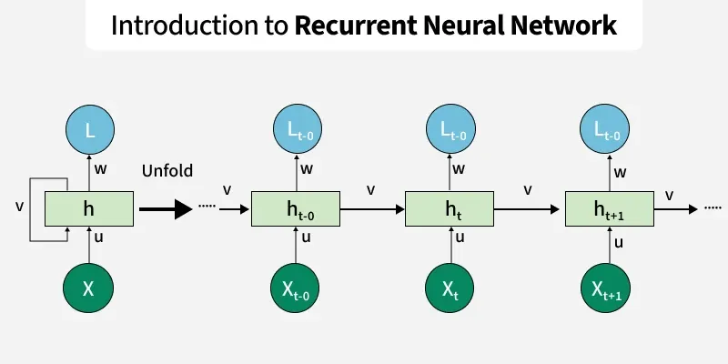
At each time step $t$:
- Input: $x_{t}$
- Previous hidden state: $h_{t-1}$
- Output hidden state: $h_{t}$
The hidden state is updated as:
$$h_{t}=f(W_{h}h_{t-1}+W_{x}x_{t}+b)$$
Where
- $W_{h}$→ hidden weights
- $W_{x}$→ input weights
- $b$→ bias
- $f$→ activation function (usually tanh)

RNN Key Characteristics
1. Hidden State Memory
The hidden state carries information from previous time steps.
Example:
Input sequence: I → love → deep → learning
The RNN remembers previous words through hidden states.

2. Weight Sharing
RNN uses the same weights at every time step.
Example:
x1 → h1 → h2 → h3 → h4
↑ ↑ ↑
same weights
Benefits:
- Fewer parameters
- Works for variable-length sequences

3. Sequential Processing
Each step depends on the previous one.
h1 → h2 → h3 → h4
So training cannot be fully parallelized.

Major Problem in RNN
Vanishing Gradient Problem
During backpropagation through time (BPTT):
Gradients become very small as they move backward through many time steps.
Result:
- Model forgets earlier information
- Cannot learn long-term dependencies
Example:
Sentence:
The boy who lived in Canada for 10 years speaks fluent English
To predict English, the model must remember boy, which is far away.
Standard RNN struggles with this.

2. Long Short-Term Memory (LSTM)
LSTM was introduced by Sepp Hochreiter and Jürgen Schmidhuber (1997) to solve the vanishing gradient problem.
LSTM introduces a memory cell and gates that control information flow.

3. LSTM Architecture
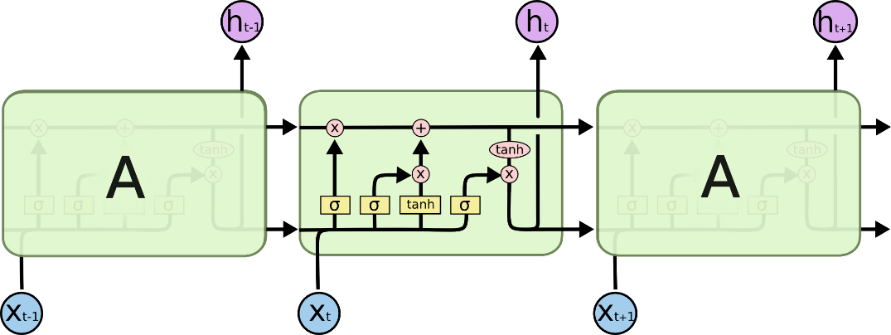
An LSTM cell contains:
- Cell State
- Hidden State
- Three Gates
  - Forget Gate
  - Input Gate
  - Output Gate

LSTM Structure
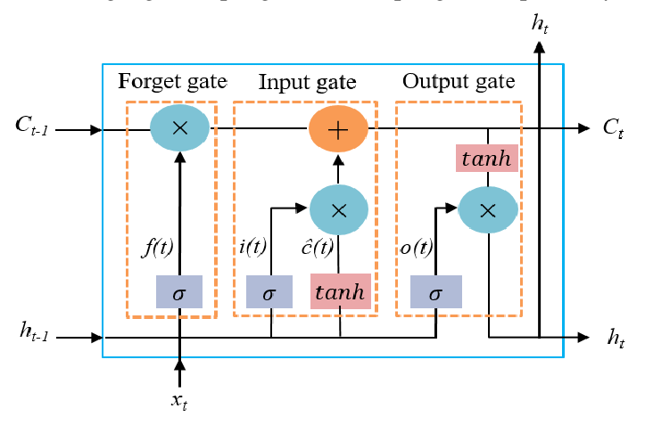
Where:
- $C_{t}$→ Cell state (long-term memory)
- $h_{t}$→ Hidden state (short-term output)

4. Important Concepts in LSTM

4.1 Cell State (Long-Term Memory)
The cell state is the main memory of LSTM.
It flows through the network almost unchanged.
C1 → C2 → C3 → C4
Gates modify this memory slightly.
Think of it like a highway for information flow.




4.2 Forget Gate
The forget gate decides what information should be removed from the cell state.
Formula:
$$f_{t}=σ(W_{f}[h_{t-1},x_{t}]+b_{f})$$
Where:
- $f_{t}$= forget gate output
- $σ$= sigmoid function
Sigmoid output range:
0 → forget information
1 → keep information
Example:
Sentence:
The clouds are in the sky
When reading sky, the network may forget clouds location earlier context.

4.3 Input Gate
The input gate decides what new information to store.
Two steps:
Step 1: Input Gate
$$i_{t}=σ(W_{i}[h_{t-1},x_{t}]+b_{i})$$
Step 2: Candidate Memory
$${\tilde{C}}_{t}=tanh(W_{c}[h_{t-1},x_{t}]+b_{c})$$
Then update cell state:
$$C_{t}=f_{t}C_{t-1}+i_{t}{\tilde{C}}_{t}$$
Meaning:
- Keep old memory
- Add new information

4.4 Output Gate
The output gate determines what part of memory becomes the hidden state.
Formula:
$$o_{t}=σ(W_{o}[h_{t-1},x_{t}]+b_{o})$$
Hidden state:
$$h_{t}=o_{t}⋅tanh(C_{t})$$
This hidden state is sent to:
- Next time step
- Output layer

5. LSTM Information Flow
Full process:
xt + ht-1
↓
Forget Gate → Remove useless memory
↓
Input Gate → Add new memory
↓
Update Cell State
↓
Output Gate → Produce ht

6. Why LSTM Solves Vanishing Gradient
Reasons:
1. Cell State Highway
Information flows directly:
Ct-1 → Ct → Ct+1
So gradients do not vanish easily.

2. Gates Control Memory
Model learns:
- what to remember
- what to forget
- what to output

3. Better Long-Term Dependency Learning
Example:
I grew up in France ... I speak fluent French
LSTM can connect France → French even with long gaps.

7. LSTM vs RNN
Feature | RNN | LSTM
Memory | Short-term | Long-term
Vanishing gradient | Major problem | Mostly solved
Architecture | Simple | Complex
Gates | No gates | 3 gates
Long sequence learning | Poor | Good
Training stability | Difficult | More stable
Parameters | Fewer | More

8. Structural Difference
RNN Cell
xt + ht-1
↓
tanh
↓
ht

LSTM Cell
xt + ht-1
↓
Forget Gate
Input Gate
Output Gate
↓
Cell State Update
↓
ht

9. Parameter Complexity
Approximate comparison:
Model | Parameters
RNN | Small
LSTM | 4× larger
Because LSTM has:
- Forget gate weights
- Input gate weights
- Output gate weights
- Candidate memory weights

10. Real-World Applications
NLP
- Machine translation
- Text generation
- Sentiment analysis
Example:
Translation systems similar to early models used by Google

Speech Recognition
Used by Apple Siri and Google voice recognition systems.

Time Series Forecasting
Examples:
- Stock prediction
- Weather forecasting
- Energy demand prediction

Video Analysis
Action recognition in videos.

11. Summary
RNN
- Designed for sequential data
- Uses hidden state memory
- Suffers from vanishing gradient
- Struggles with long sequences

LSTM
- Improved RNN architecture
- Uses cell state + gates
- Handles long-term dependencies
- Prevents vanishing gradient

